ASSIGNMENT 12.4
HALL NO:2403A52141
BATCH NO:06
TASK-1:
Write a Python implementation of Bubble Sort.
• Instructions:
o Students implement Bubble Sort normally.
o Ask AI to generate inline comments explaining key
logic (like swapping, passes, and termination).
o Request AI to provide time complexity analysis
CODE:
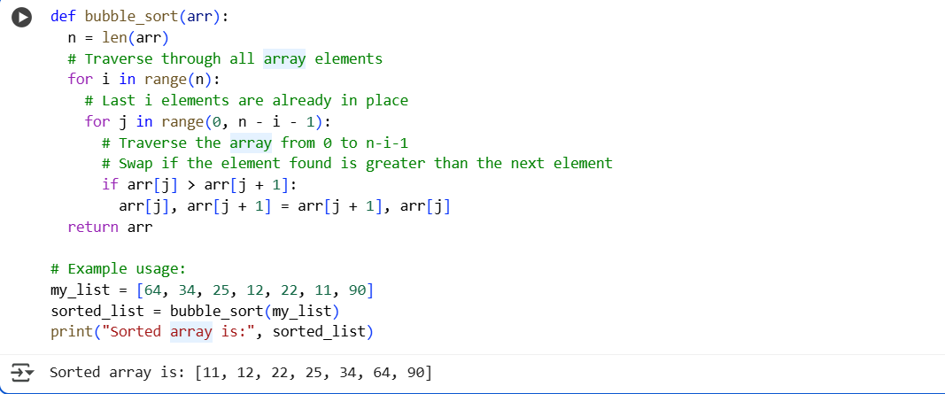
OUTPUT:
EXPLANATION:
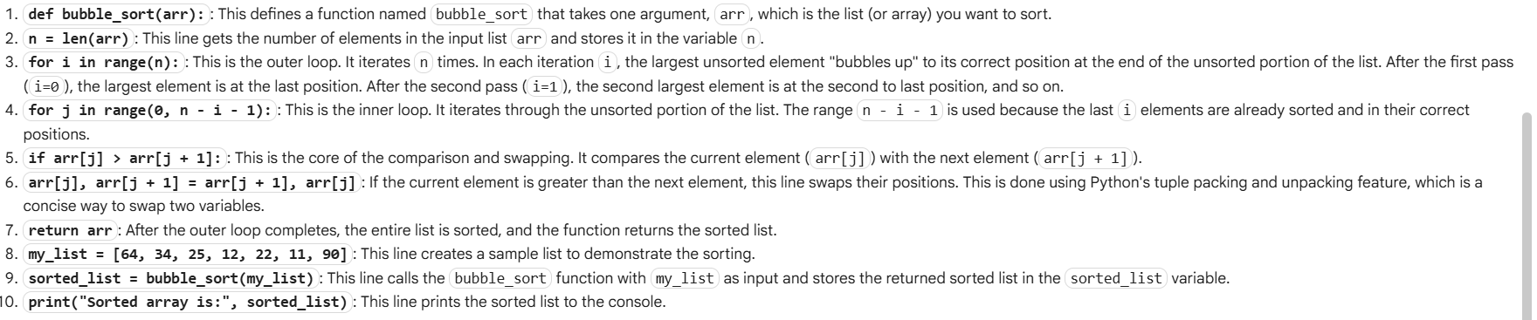

TASK-2:
Provide Bubble Sort code to AI and ask it to suggest a
more efficient algorithm for partially sorted arrays.
• Instructions:
o Students implement Bubble Sort first.
o Ask AI to suggest an alternative (Insertion Sort).
o Compare performance on nearly sorted input
CODE:
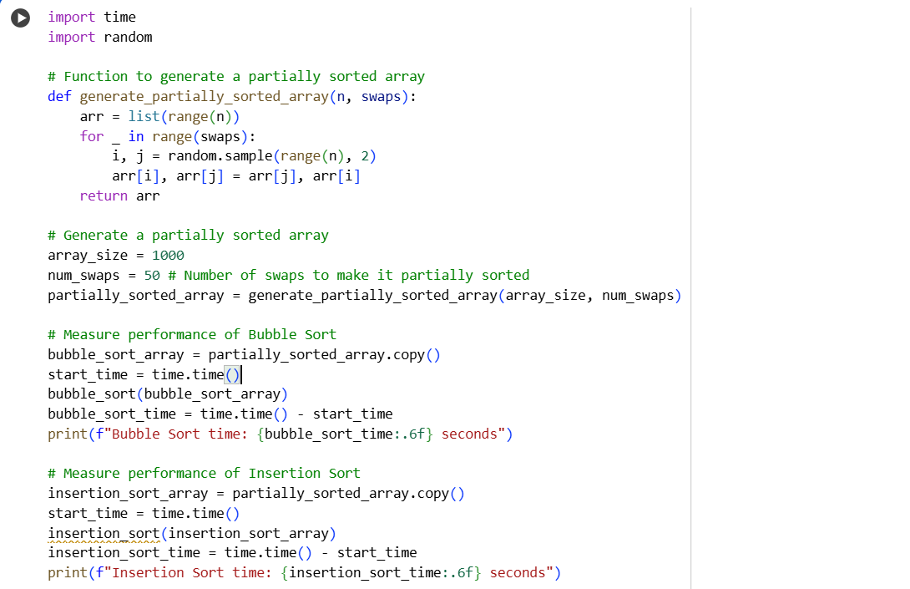
OUTPUT:
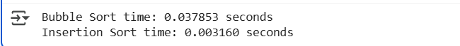
EXPLANATION:
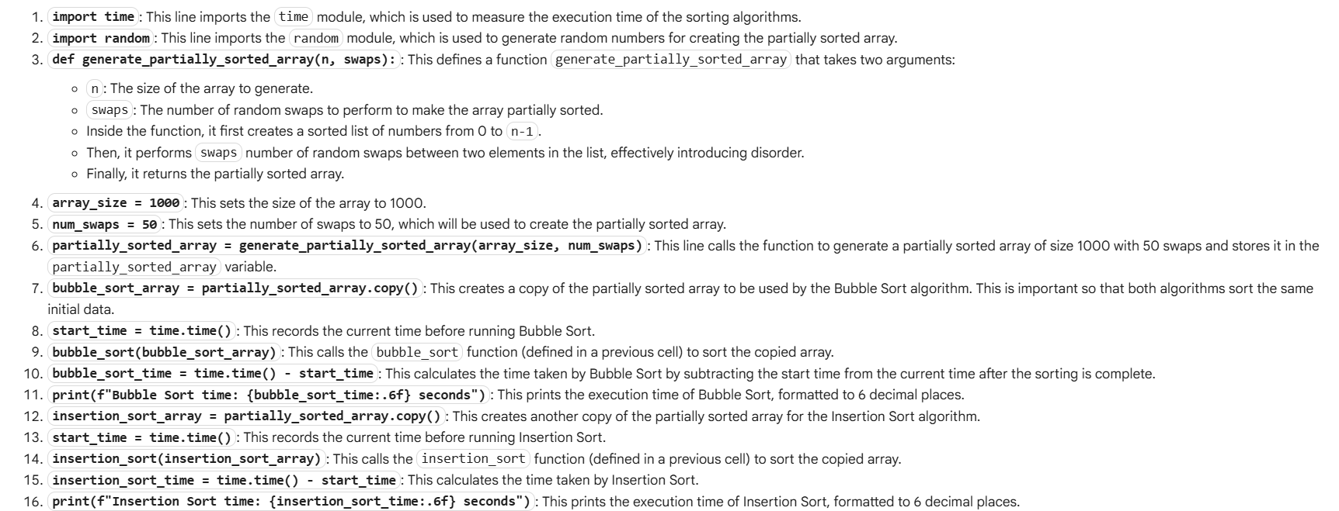
TASK-3:
Implement both Linear Search and Binary Search.
• Instructions:
o Use AI to generate docstrings and performance notes.
o Test both algorithms on sorted and unsorted data.
o Ask AI to explain when Binary Search is preferable.
CODE:
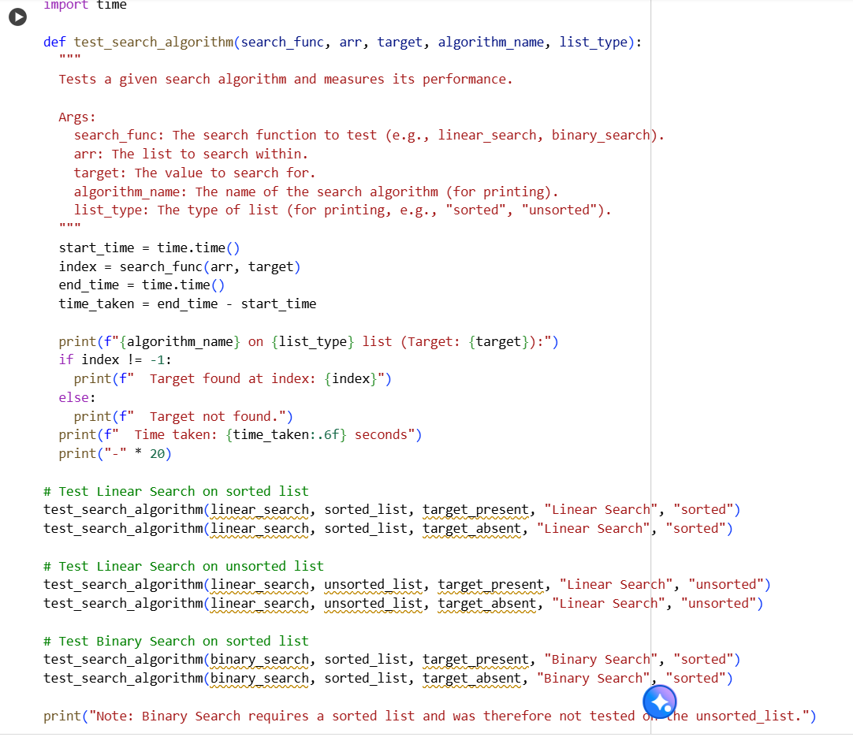
OUTPUT:
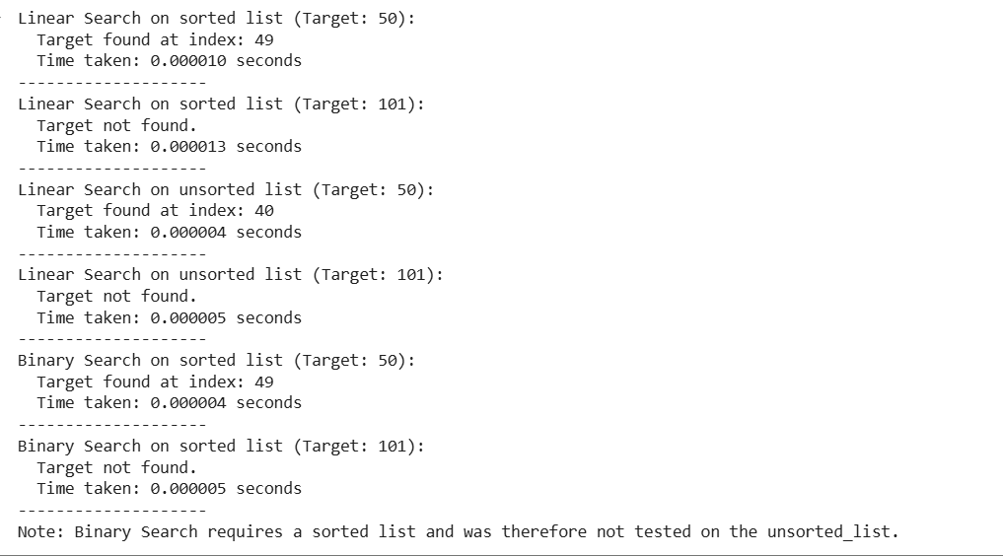
EXPLANATION:
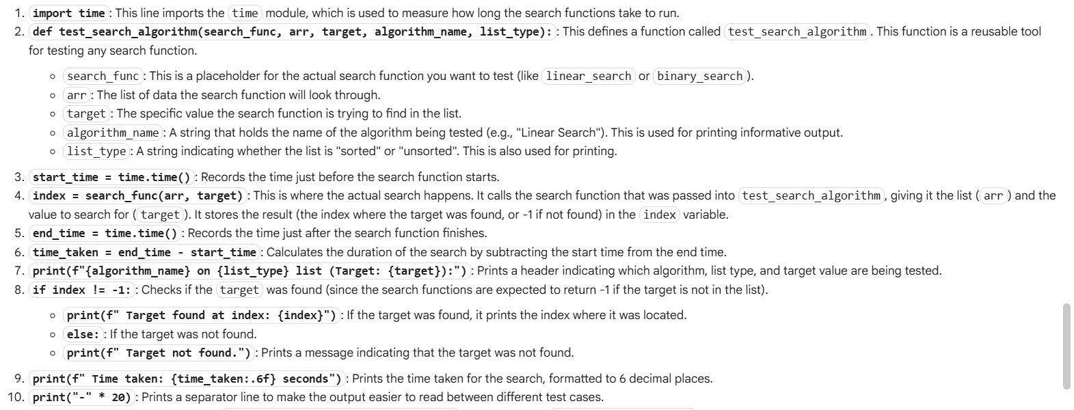
TASK-4:
mplement Quick Sort and Merge Sort using recursion.
• Instructions:
o Provide AI with partially completed functions for
recursion.
o Ask AI to complete the missing logic and add docstrings.
o Compare both algorithms on random, sorted, and reverse-
sorted lists
CODE:
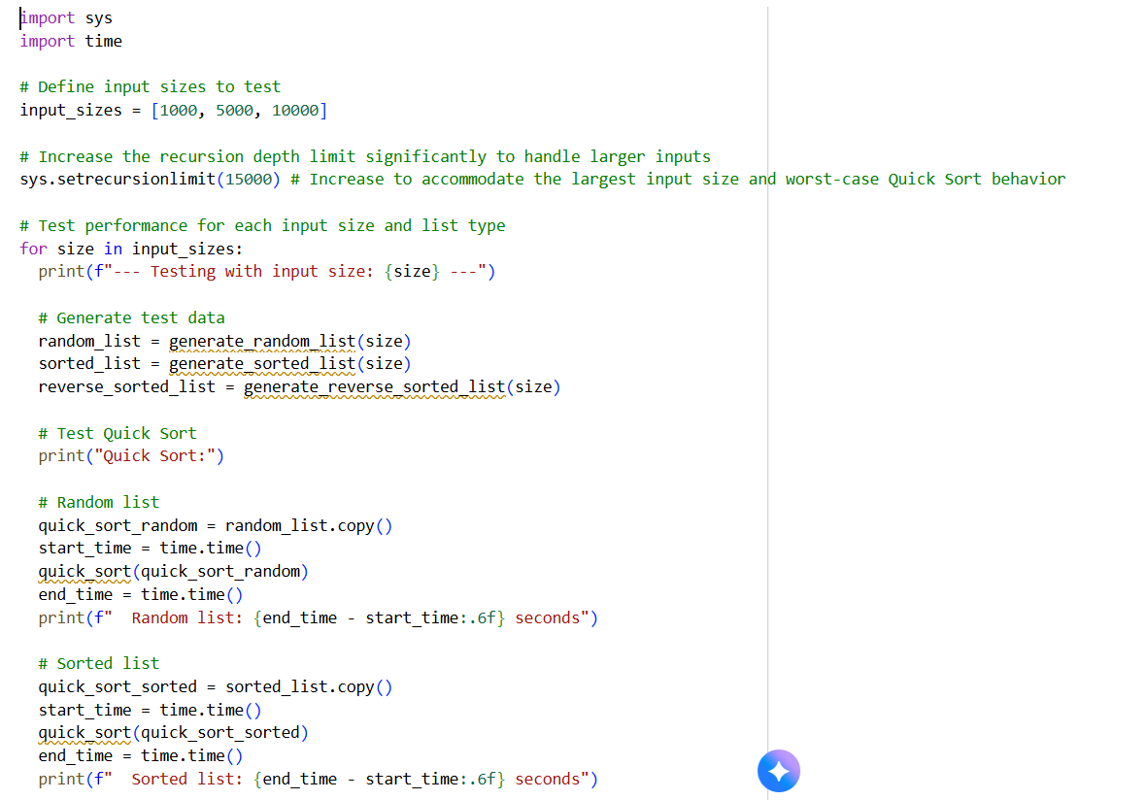
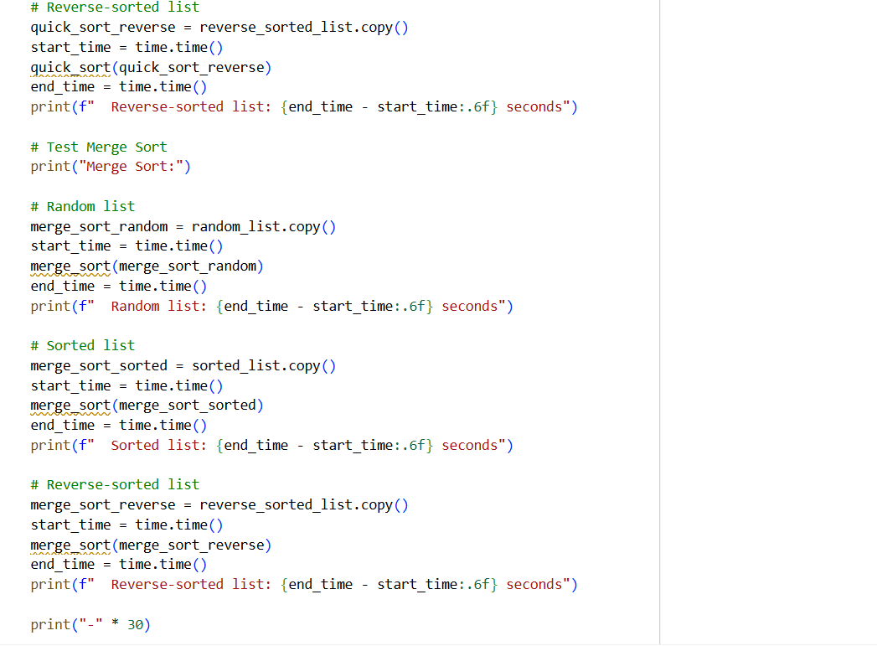
OUTPUT:
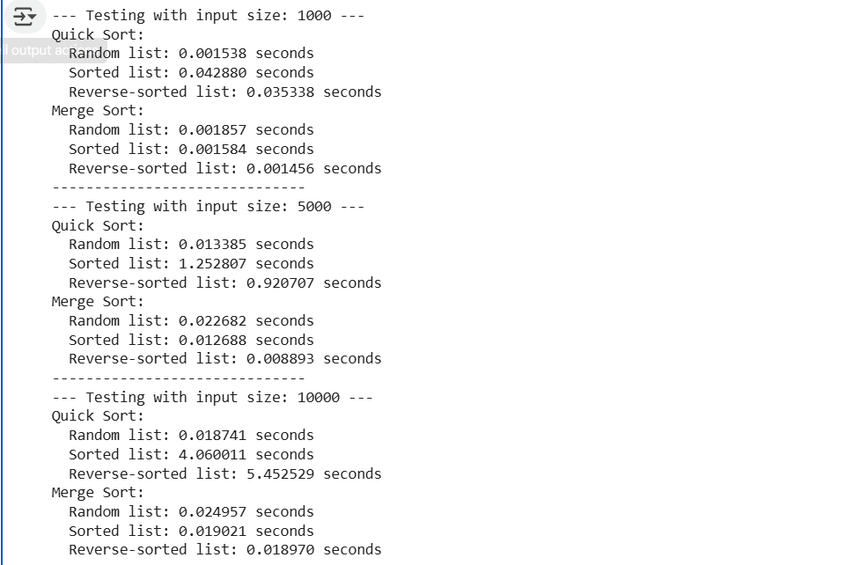
EXPLANATION:
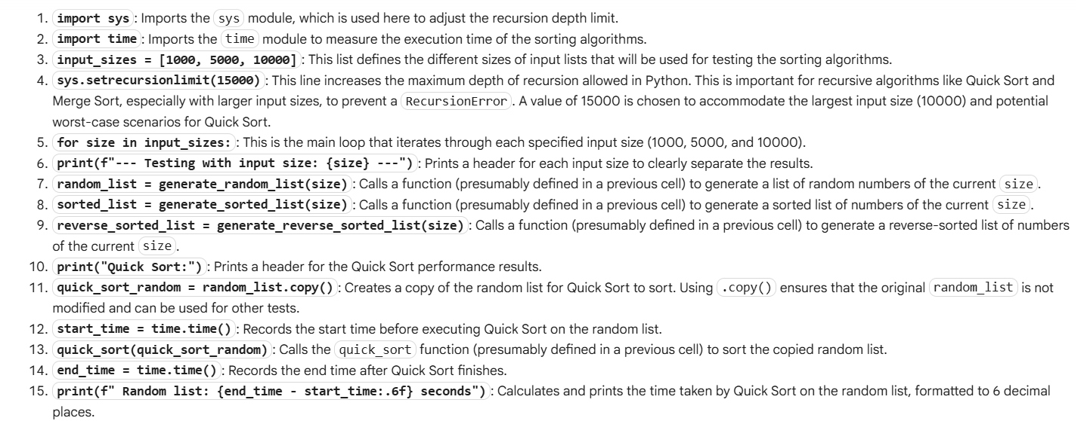
TASK-5:
ive AI a naive algorithm (e.g., O(n²) duplicate search).
• Instructions:
o Students write a brute force duplicate-finder.
o Ask AI to optimize it (e.g., by using sets/dictionaries with
O(n) time).
o Compare execution times with large input sizes
CODE:
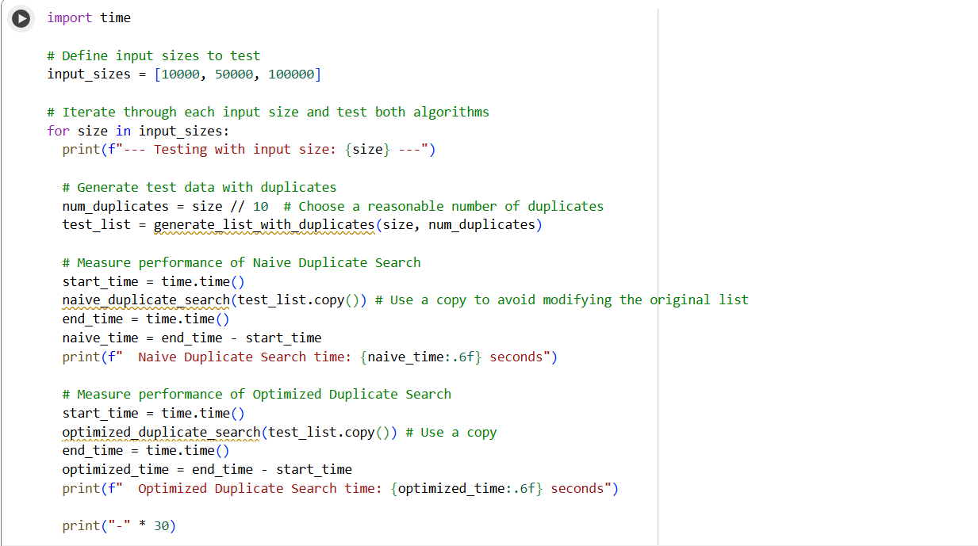
OUTPUT:
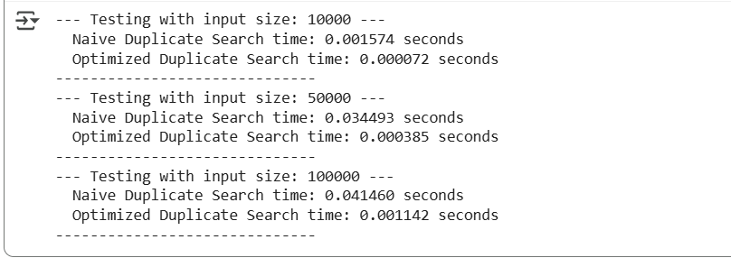
EXPLANATION:
